THIS WEEK I WILL:

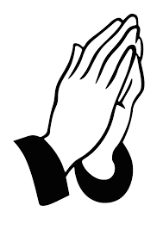pray for

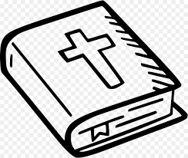

read my Bible every

**____________________________**

WORDS I HEARD IN CHURCH TODAY: CIRCLE EACH WORD YOU HEAR

 BIBLE PRAY LOVE 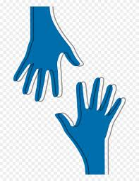 SERVE 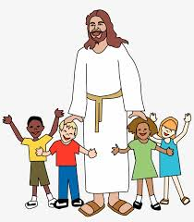 JESUS

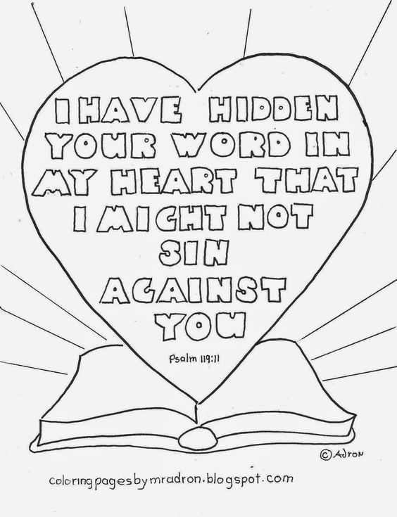





BIBLE

STUDY

_____________________________________________________________________________________________________________________

WHAT I LEARNED IN CHURCH TODAY

DRAW A PICTURE OF WHAT YOU LEARNED TODAY

DRAW A

OLD TESTAMENT NEW TESTAMENT