Today we talked about Jesus as our:

(check all that apply)

□ Savior □ Healer □ ________________

□ Comforter □ Hope □ ________________

**WHAT IS THE MAIN POINT OF THE SERMON?** ______________________________________________________________________________________________________________________________________________________________________________________________________________________________

**THE MOST IMPORTANT THING I LEARNED TODAY IS:** _________________________________________________________________________________________________________________________________________________________________________________________

_____________________________________

**HOW CAN I USE THIS IN MY LIFE?**_______________________________________________________________________________________________________________________________________________

Write one word in the banner to remember this week.

Listen and check each word you hear today:

God Faith

Bible Sin

Jesus Forgive

Love Bible

Truth ____________

Grace ____________

Cross ____________

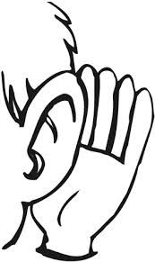

____________________________________________________________

WORDS I HEARD THAT I DON’T KNOW:

DATE: _________________________

SPEAKER: ______________________

SCRIPTURE: ____________________

____ Old Testament ____ New Testament



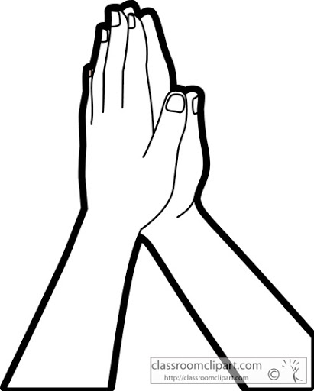THIS WEEK I WILL PRAY FOR:

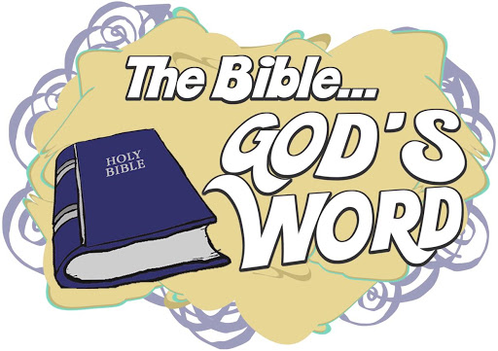

SERMON NOTES

